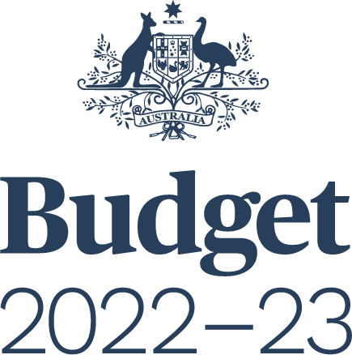

FINAL BUDGET OUTCOME
2022–23

Statement by
The Honourable Jim Chalmers MP
Treasurer of the Commonwealth of Australia
and
Senator the Honourable Katy Gallagher
Minister for Finance, Minister for Women,
Minister for the Public Service of the Commonwealth of Australia

For the information of honourable members
September 2023

© Commonwealth of Australia 2023
ISSN: 2205 6750 (Print) 2205 6769 (Online)
This publication is available for your use under a Creative Commons BY Attribution 3.0 Australia licence, with the exception of the Commonwealth Coat of Arms, third party content and where otherwise stated. The full licence terms are available from http://creativecommons.org/licenses/by/3.0/au/legalcode.
Use of Commonwealth of Australia material under a Creative Commons BY Attribution 3.0 Australia licence requires you to attribute the work (but not in any way that suggests that the Commonwealth of Australia endorses you or your use of the work).
Commonwealth of Australia material used ‘as supplied’
Provided you have not modified or transformed Commonwealth of Australia material in any way including, for example, by changing the Commonwealth of Australia text; calculating percentage changes; graphing or charting data; or deriving new statistics from published Commonwealth of Australia statistics – then Commonwealth of Australia prefers the following attribution:
Source: The Commonwealth of Australia.
Derivative material
If you have modified or transformed Commonwealth of Australia material, or derived new material from those of the Commonwealth of Australia in any way, then Commonwealth of Australia prefers the following attribution:
Based on Commonwealth of Australia data.
Use of the Coat of Arms
The terms under which the Coat of Arms can be used are set out on the Department of the Prime Minister and Cabinet website (see www.pmc.gov.au/
honours-and-symbols/commonwealth-coat-arms).
Other uses
Enquiries regarding this licence and any other use of this document are welcome at:
Manager
Communications
The Treasury
Langton Crescent
Parkes ACT 2600
Email: media@treasury.gov.au
Internet
A copy of this document is available on the central Budget website at: www.budget.gov.au.
Printed by CanPrint Communications Pty Ltd.
Notes
- The following definitions are used in this Budget Paper:
  - ‘real’ means adjusted for the effect of inflation
  - real growth in expenses and payments is calculated using the Consumer Price Index (CPI) as the deflator
  - one billion is equal to one thousand million.
- Figures in tables and generally in the text have been rounded. Discrepancies in tables between totals and sums of components are due to rounding:
  - figures under $100,000 are rounded to the nearest thousand
  - figures $100,000 and over are generally rounded to the nearest tenth of a million
  - figures midway between rounding points are rounded up
  - the percentage changes in statistical tables are calculated using unrounded data.
- For the budget balance, a negative sign indicates a deficit while no sign indicates a surplus.
- The following notations are used:
 | nil
na | not applicable (unless otherwise specified)
.. | not zero, but rounded to zero
$m | millions of dollars
$b | billions of dollars
NEC/nec | not elsewhere classified

- The Australian Capital Territory and the Northern Territory are referred to as ‘the territories’. References to the ‘states’ or ‘each state’ include the territories. The following abbreviations are used for the names of the states, where appropriate:
NSW | New South Wales
VIC | Victoria
QLD | Queensland
WA | Western Australia
SA | South Australia
TAS | Tasmania
ACT | Australian Capital Territory
NT | Northern Territory
- In this paper the term Commonwealth refers to the Commonwealth of Australia. The term is used when referring to the legal entity of the Commonwealth of Australia.
The term Australian Government is used when referring to the Government and the decisions and activities made by the Government on behalf of the Commonwealth of Australia.

Contents

Preface vii
Part 1: Australian Government Budget Outcome 2022–23 1
Overview 1
Budget aggregates 3
Underlying cash balance 3
Primary balance 8
Net operating balance and fiscal balance 8
Headline cash balance 13
Gross debt, net debt, net financial worth and net worth 14
Part 2: Australian Government Financial Statements 17
Australian Government Financial Statements 18
Financial reporting standards and budget concepts 50
Part 3: Australia’s Federal Financial Relations 59
Overview of payments to the states 59
Payments for specific purposes 60
General revenue assistance 64
Payments to the states 69
Appendix A: Expenses by Function and Sub-function 89
Appendix B: Historical Australian Government Data 93
Data sources 93
Comparability of data across years 93
Revisions to previously published data 95

Preface
The Final Budget Outcome for 2022–23 has been prepared in a manner consistent with the Charter of Budget Honesty Act 1998 (the Charter). The Charter requires that the Government provide a final budget outcome report no later than 3 months after the end of the financial year. Consistent with these requirements, this report encompasses Australian Government general government sector fiscal outcomes for the 2022–23 financial year and is based on external reporting standards.
- Part 1 provides the general government sector budget aggregates for 2022–23 together with an analysis of the Final Budget Outcome for 2022–23. This includes summary analysis of cash flows, revenue, expenses, net capital investment and the balance sheet (net debt, net financial worth and net worth).
- Part 2 presents the Australian Government financial statements for 2022–23 with the Australian Bureau of Statistics’ (ABS) Government Finance Statistics (GFS) as the basis for accounting policy, except for where the Government has decided to depart because Australian Accounting Standards provide a better conceptual treatment for presenting information of relevance to users of public sector financial reports. This data covers the general government sector as well as the Australian Government public corporations sectors.
- Part 3 provides details for 2022–23 on Australia’s Federal Financial Relations, updated from that contained in the 2023-24 Budget Paper No. 3, Federal Financial Relations.
Appendix A contains expenses data on a functional and sub-functional basis. Historical Australian Government data are presented in Appendix B.

